22.05.2020
Press Release with request for coverage
22nd May- Nationwide protest day observed by the trade unions
Demanding withdrawl of draconian changes in labour laws.
Hunger strike, demonstrations, processions and arrests at several places.
Petitions to Prime Minister sent from all over India listing demands
22nd May - Nationwide protest on the call of 10 Central Trade Unions was joined by several other trade unions active at National and State level. A Joint Petition by the Central Trade Unions(CTUs) was submitted to the Prime Minister via e mail. This petition was simultaneously released all over India by the participating leaders and activists. The petition included the demands such as immediate relief to stranded workers for safe reaching to their homes, food to be made available to all, universal coverage of ration distribution without conditions, ensure wages to all of the entire lock down period, cash transfer of Rs.7500/- to all non-income tax paying households including unorganized labour force (registered or unregistered or self employed) for at least three months i.e. April, May and June, withdraw DA freeze to central government employees & CPSEs and DR freeze to pensioners, stop surrendering of live sanctioned posts, put a complete halt to any changes/dilutions in the labour laws, strengthen of the Inter State Migrant Workmen (Regulation of Employment and Conditions of Services) Act 1979 to ensure compulsory registration of migrant workers ensuring with adequate protective provisions on wages, social security, accommodation and welfare needs with a strong and accountable enforcement mechanism. They demanded halt to the policy of wholesale privatization PSUs and government departments through multi-pronged routes like corporatization, outsourcing, PPP, liberalized FDI etc, which were reiterated and announced during the package announcements by the FM from 13th May to 17th May 2020 in particular and also in the addresses of the Prime Minister during lock down period.
The employees and workers from independent federations and associations such as banks, insurance, defense, telecom, central and state government employees etc. organized solidarity actions by wearing black badges in some cases and lunch hour meetings in other establishments and some participating in the action programmes directly. The unions of oil sector in Assam and Arunachal Pradesh were also in protest action. The coal unions in Jharkhand, Chhatisgarh, Odisha, Telengana, Madhya Pradesh and Maharashtra were in protest action. Hunger strike was resorted to in several states at some selected spots such as in Delhi, Telangana, Assam, Bihar, Chhatisgarh, Punjab, Tamilnadu, Pudduchery, Orissa and Andhra Pradesh. In Tamilnadu the programme was organized in 8000 places with more than a lakh people, similarly the programmes in Kerala were organized in 5000 places with participation of more than one lakh persons. In Goa the programmes were organized in almost all industrial unit where AITUC has presence. In Maharashtra the programmes could be organized in about 36 districts. In Haryana and Punjab the programmes were held in almost all districts and memorandum submitted to DC offices in several of them. In Odisha also the programmes were organized in all the districts as well as in the industrial areas of Rourkela, Sambalpur, Paradeep and in NCL areas. In Uttar Pradesh the programmes were organized in most of the districts and memorandum submitted to the concerned officials to pass on to State and Central Govt. There were programmes held in Himachal Pradesh and Uttrakhand in Mussoori, in BHEL in Haridwar and industrial areas. Madhya Pradesh and Rajasthan witnessed joint action at several places In Manipur, Arunanchal Pradesh, Tripura also the protest actions were organized..The workforce in Oil sector in Duliajan in Assam organized a programme of protests. There were reports that though the scheme workers-Aanganwadi, ASHA were on their duties of door to door visits for screening and making data etc. related with COVID 19 despite that they could participate in programmes in several parts of the country. In Meghalaya the programme was banned by the administration. In West Bengal the programmes were suspended in the cyclone affected areas, whereas in other places the programmes could be conducted including in Tea plantation areas. In Karnataka also the day was observed, the state leadership of trade unions submitted petition to PM and their own memorandum.
In Delhi the programme was held in several places including the programe of hunger strike at Gandhi Samadhi, Rajghat where some of the national leadership of the Central Trade Unions participated along with the leaders of Delhi units of CTUs. Some of the protesting leaders were arrested and taken to Rajendra Nagar police station.Those arrested included HMS General secretary Harbhajan Sidhu, CITU General Secretary Tapan Sen, AICCTU General Secretary Rajeev Dimri, AITUC national secretary, Vidya Sagar Giri, Ashok Singh Vice President of INTUC, R K Sharma National Secretary of AIUTUC, Jawahar Singh of LPF, Lata Ben and Usha from SEWA,Trilok Singh national leader from General insurance, Hemlata and Amitav Guha of CITU and Rajender Singh of HMS.
INTUC President Sanjeeva Reddy participated in the programme at Hyderabad whereas AITUC General Secretary Amarjeet Kaur was part of the procession and then protest at Mini Secretariat in Ludhiana. The General Secretary LPF Shanmugam attended action in Tamilnadu.TUCC national leaders G Shivshankar and Devrajan were present in the programmes in Karnataka and Kerala.The General Secretary of SEWA, Ms Manali attended programme in Gujrat.
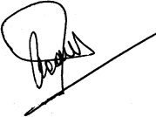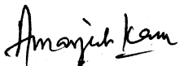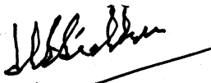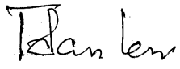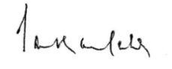
INTUC AITUC HMS CITU AIUTUC
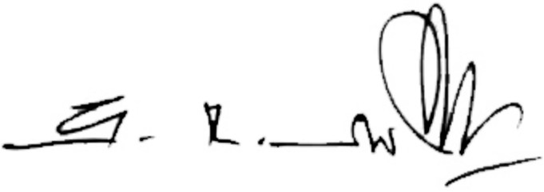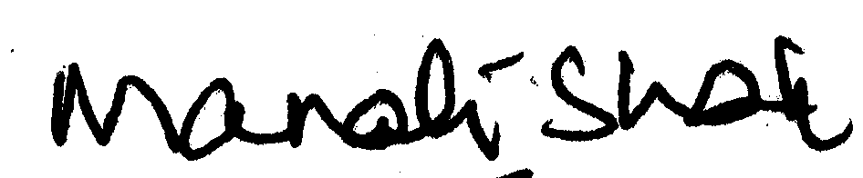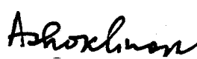
TUCC SEWA AICCTU LPF UTUC

